**About:**

**概括介绍下面可视化的是啥**

**Visualization Tool:**

**说一下用到那些可视化元素图表，为什么选这些图表，颜色形状等含义介绍**

**1.Identify the relationship between economy and agriculture structure.**

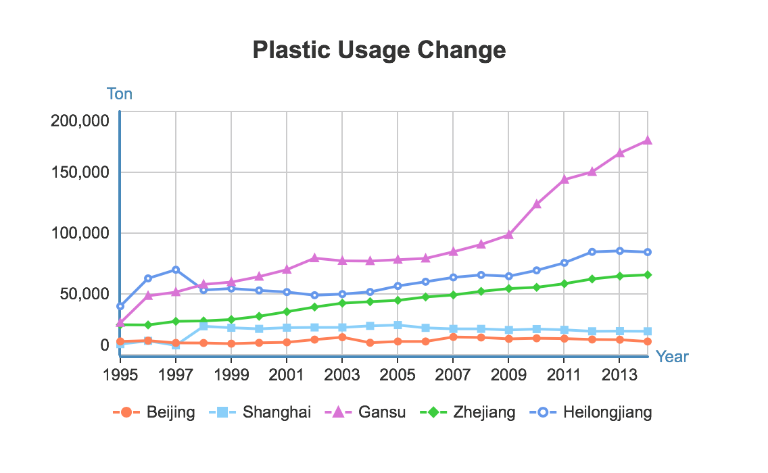

The first picture above shows the plastic usage change from 1995 to 2014. The purpose is to show how the amount of environment-unfriendly material changes together with the development of agriculture economy. I chose 5 different provinces and noticed that the more developed the city is, the less plastic it relies on. So I want to choose another different environment-unfriendly material and show how it changed during the same time.

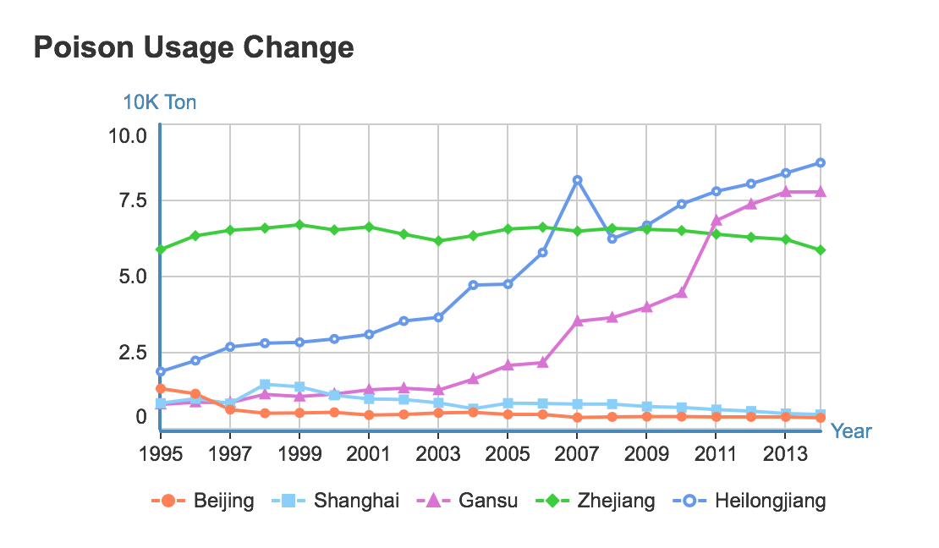

This picture above shows the poison usage change of the same 5 provinces in the first picture. We can easily observe from the chart that although Zhejiang province used a large amount of poison as always, the figure stayed stable. Beijing and Shanghai also remained unchanged even drop down a little. By contrast, the figure of Gansu and Heilongjiang increased dramatically since 2003. Then I wonder how the economy of these provinces distributes.

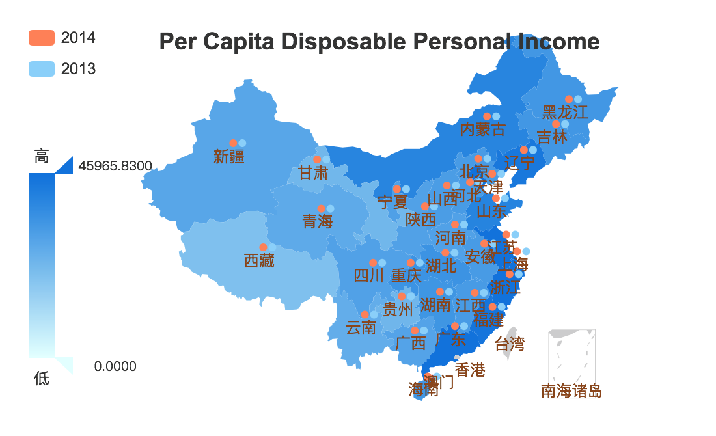

The picture above illustrates the per capita disposable personal income based on a Chinese map. And I get the information I want. Zhejiang, Shanghai and Beijing are all very developed city/province, but Heilongjiang and Gansu both have a comparably low income level. So by the visualization above it seems that as the development of the economy, people will use less and less environment-unfriendly material in agriculture.

**2. Identify the role of agriculture in different economy structure.**

In my opinion, development determines the economy structure. So I decide to dig much deeper into the agriculture development of the most developed cities in China which are Beijing and Shanghai.

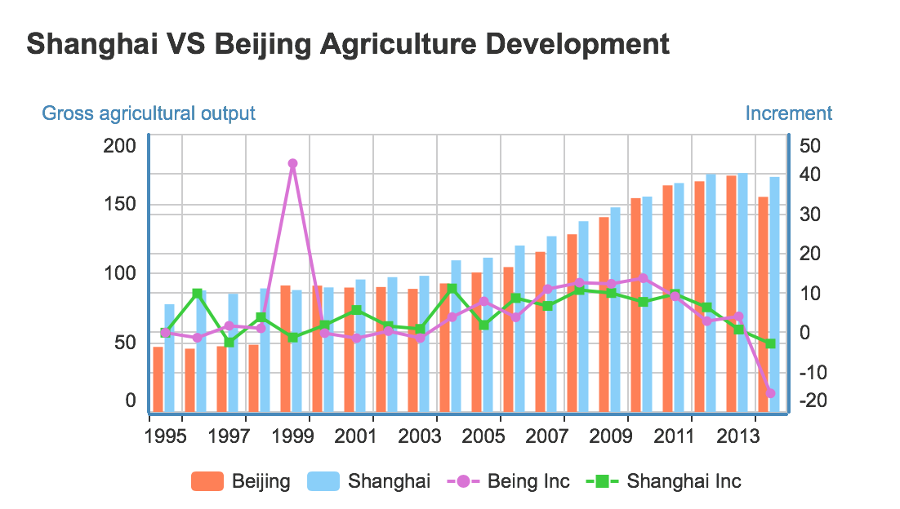

As you can see from the visualization showed above. The gross agricultural output of Beijing and Shanghai both gradually increase but at a slower and slower pace. In the end, the increment become negative, which means the agriculture becomes a less and less important part of the cities’ economy.

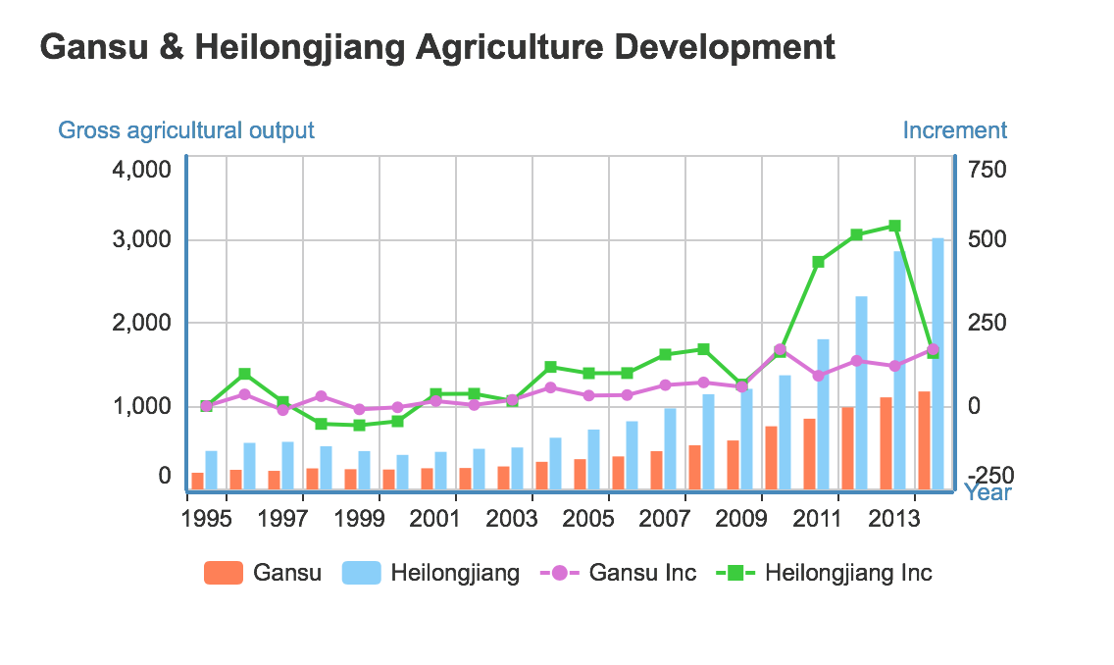

By contrast, I visualize the data of Gansu and Heilongjiang, the visualization result is showed above. I find that both of these two provinces’ gross agriculture output are increasing steadily. This means that the agriculture development of these two cities are still in an upward trend. So in some provinces that are not as developed as Beijing and Shanghai, agriculture seems to play a much more important role in local economy.

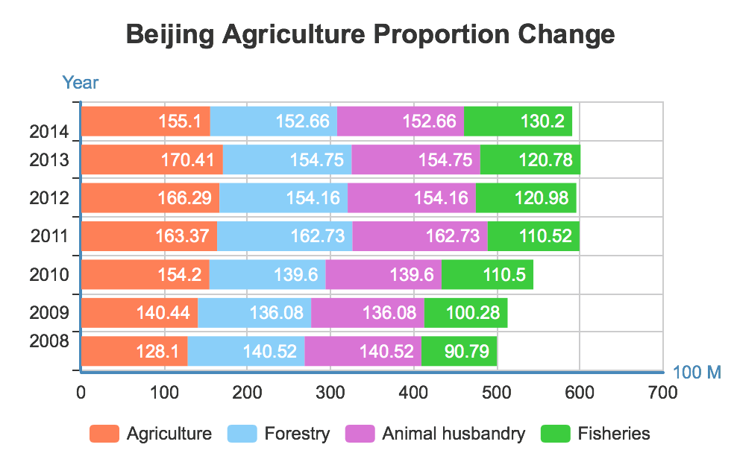

This picture above shows the different categories of primary industry in Beijing. Three out of four categories remains stable in gross output and it can reflect my conclusion above. What’s interesting is that Fishery seems to develop well in Beijing.